**Burn UF2-SAMD bootloader instruction**

This guide will cover wiring a J-Link to a SAMD board, flashing the bootloader, and installing the latest CircuitPython build (optional).

This process does require extra hardware and some software installation time. It is unfortunate when a microcontroller’s firmware is corrupted - it does not happen often. But, rather than buy a new board and have one sitting, this process will get your original board back to 100%

**About the SAMD UF2 Bootloader**

You will need to program the [UF2-SAMD Bootloader](https://github.com/adafruit/uf2-samdx1) onto the affected board. SAMD21 (M0) boards feature an improved bootloader that make it easier than ever to flash different code onto the microcontroller.

**Parts**

To flash the bootloader, you’ll need a JTAG/SWD debugger. The [J-Link Bass](https://www.adafruit.com/product/2209) (for commercial user) is needed. You may also want to get a [JTAG to SWD converter board](https://www.adafruit.com/product/2094) and [SWD cable](https://www.adafruit.com/product/1675), and a SWD [breadboard breakout](https://www.adafruit.com/product/2743).

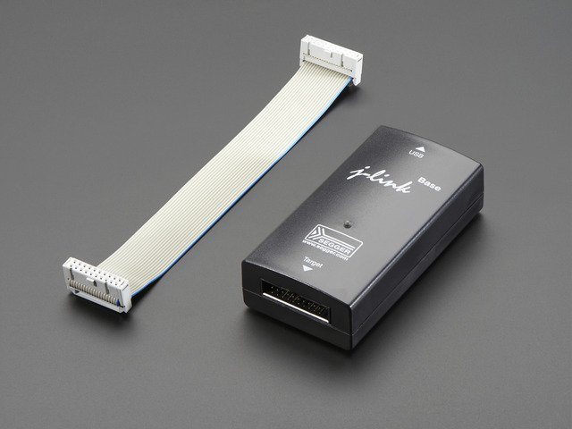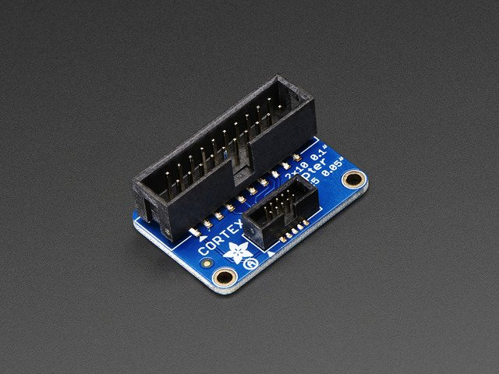

**SEGGER J-Link Base JTAP to SWD**

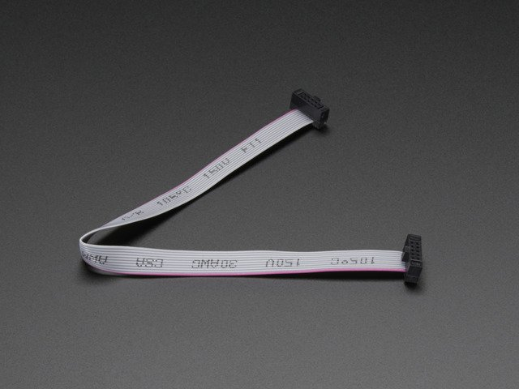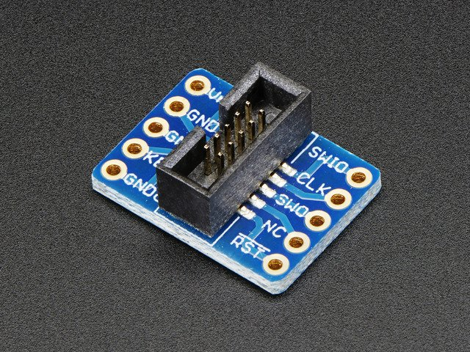

**SWD Cable SWD Cable Breakout Board**

**Setup**

1. Installing J-Link

Navigate to the [Seger downloads page](https://www.segger.com/downloads/jlink" \l "J-LinkSoftwareAndDocumentationPack) and install the version of the J-Link Software and Documentation Pack for your operating system:

**Grab a Bootloader**

You’ll also want to download a [compiled bootloader binary](https://github.com/adafruit/uf2-samdx1/releases) (.bin file) for the board you’re recovering.

**Wiring**

Wiring method may change based on the board design.

There are two programming pads located at the bottom of the Trinket M0:

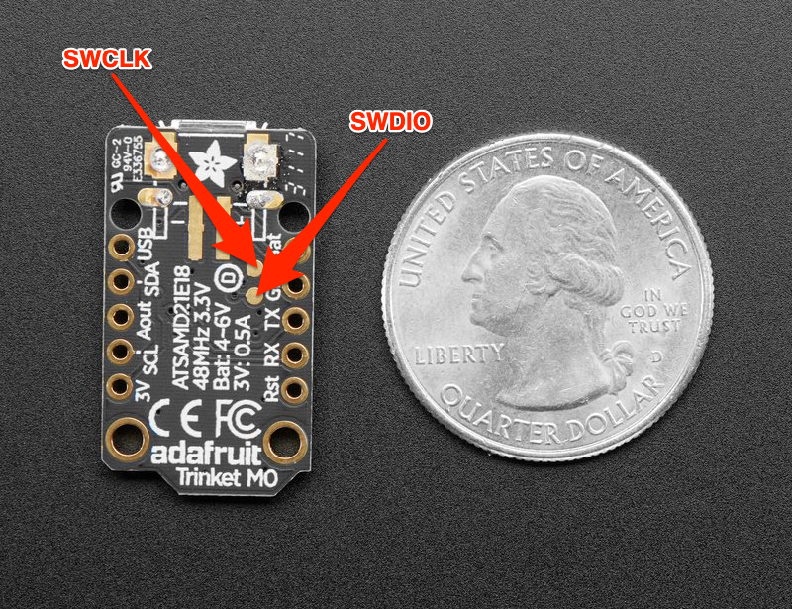

Cut and strip two wires. Solder one of them to the SWDIO pad and the other to the SWCLK pad, making sure that the two wires do not touch.

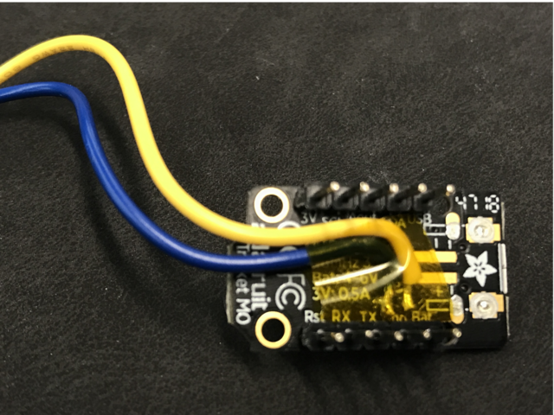

Then, make the following connections between the Trinket and the SWD breakout:

* Trinket SWDIO to Breakout SWIO
* Trinket SWCLK to Breakout CLK
* Trinket 3Vo to Breakout VRef
* Trinket GND to Breakout GND

**Programming the Bootloader with Atmel Studio**

You’ll need to **[install Atmel Studio 7](http://studio.download.atmel.com/7.0.1931/as-installer-7.0.1931-web.exe)**. This software is **free** and **only works on a Windows host computer**.

**Setting up JLink for Atmel Studio**

Jlinks ship with the firmware they are programmed with from the factory. We’ll want to update ours to the latest version.

From the Windows search bar, search for the **Jlink Configurator** application and launch it.

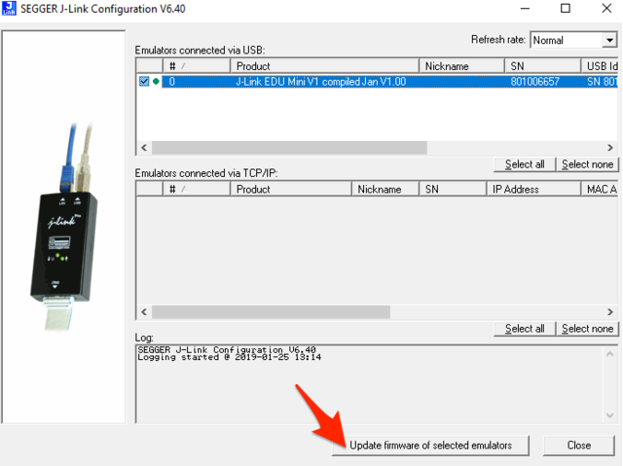

The JLink Configurator tool will show all connected devices. Tick the box next to the JLink you want to update. Then, click **Update Firmware of Selected Emulators.**

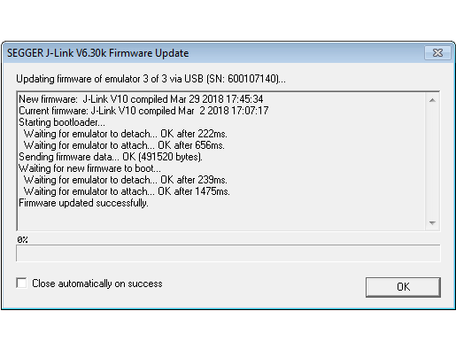

If a new firmware is available, the JLink will launch a pop-up window, updating the firmware.

Next, launch the SEGGER JLink DLL updater from the start menu. If there is an update available for Atmel Studio 7, **tick the checkbox** and click **OK** to update Atmel Studio 7’s the latest JLink software.

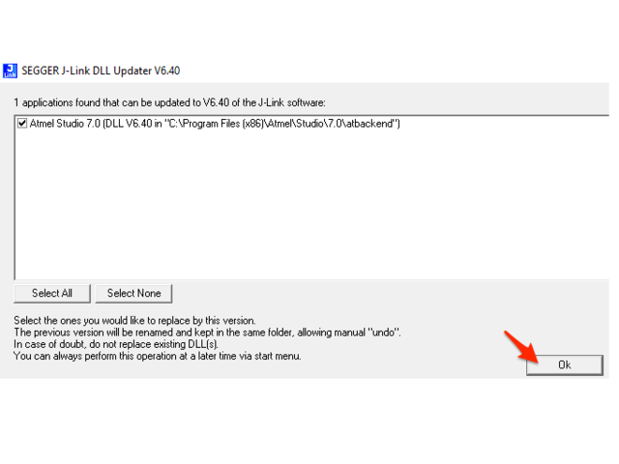

Next, open Atmel Studio. From the toolbar, **select Tools->Device Programming**.

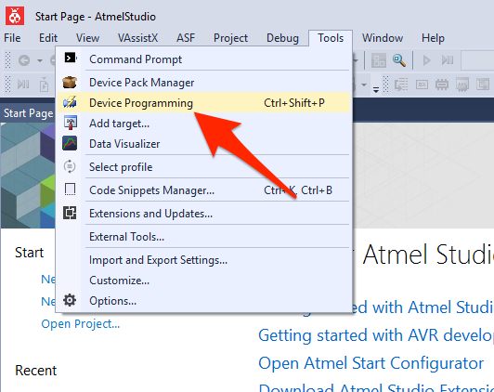

The device programming window will open. Before we proceed, make sure your J-Link and board are both plugged into your computer.

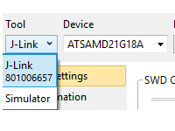

Them, **select Tool->J-Link**.

**Flashing a SAMD21 M0 Board with Atmel Studio**

Next, we’re going to **select the Device (the type of chip)**, for our board, select ATSAMD21E18A**.** Click Apply.

Make sure your board is plugged into USB, then click **Read**. The empty fields for *Device Signature* and *Target Voltage* will populate.

**Make sure these values appear before proceeding!**

* If the board is not detected, or your wiring is not detected, Atmel Studio will throw an error that it could not connect to the board. Check your wiring (especially the SWDIO/SWCLK wires), that your USB cables are connected to the computer, and try to connect again.
* Be sure your USB cable is a USB data cable and not a “Cell phone charging” power only cable. The data lines are needed to communicate between your computer and the J-LINK.

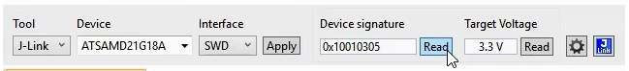

The SAMD21 has a **BOOTPORT** fuse protecting the flash area of the bootloader. You’ll want to clear the **BOOTPORT** fuse before flashing the bootloader.

For SAMD21, you will need to set it to 0×07

**Click Program**, wait for a confirmation that the fuses have been set. Then, **Click Verify**.

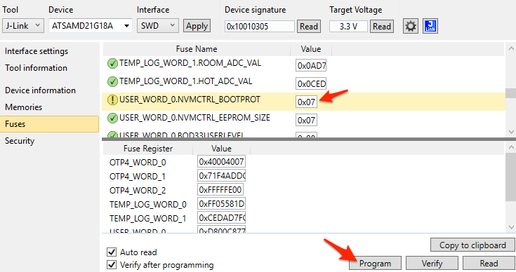

On the sidebar, **click Memories.**

**Select the bootbloader** for the CircuitPython board you’re recovering (the .bin file you downloaded earlier).

**Select Erase Flash before programming and *Verify flash after programming.***

Then, **click Program.**

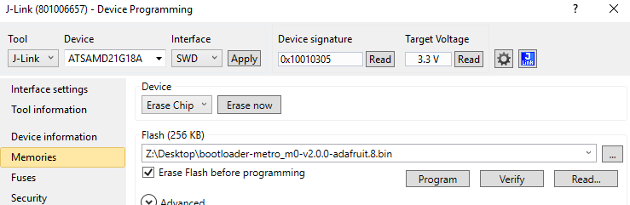

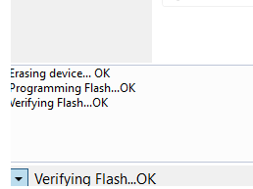After clicking **Program**, the serial will output:

Erasing Device...OK

Programming Flash...OK

Verifying Flash...OK

After flashing, you’ll need to set the BOOTPORT fuse to a 8kB bootloader size.

From **Fuses, set** BOOTPORT **to 0×2** and **click Program**

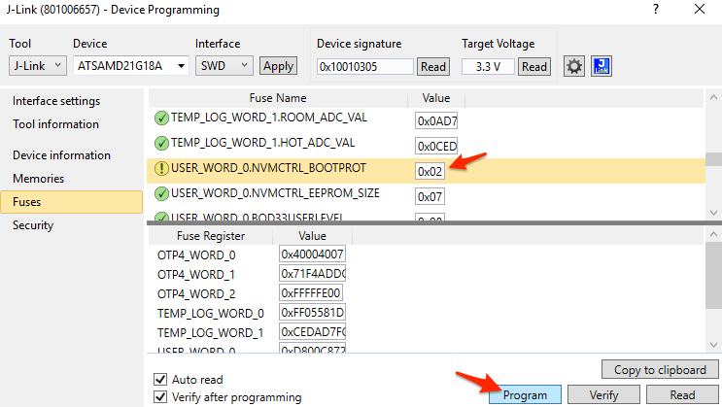

Open Windows Explorer-there should be a new volume mounted on your machine indicating that the board has been programed with the UF2 bootloader: